Birla Institute of Technology & Science, Pilani
Work Integrated Learning Programmes Division
First Semester 2023-2024

Mid-Semester Test
(EC-2 Regular)

Course No. : CSI ZG527
Course Title : Cloud Computing
Nature of Exam : Closed Book
Pattern of Exam : Typed Only
Weightage : 35%
No. of Pages = 4

No. of Questions = 5
Duration : 2 Hours
Date of Exam : 24/09/2023 (AN)
Note to Students:
- Please follow all the Instructions to Candidates given on the cover page of the answer book.
- All parts of a question should be answered consecutively. Each answer should start from a fresh page.
- Assumptions made, if any, should be stated clearly at the beginning of your answer.

- Read the below case study and answer the questions Marks 5+2+4+4 =15

Aayush hospitals is a name to reckon in modern medical care providing excellent medical care and services to patients in India & abroad. However, their backend IT systems (billing, payroll, insurance processing, claims administration) were many and mostly comprised of legacy applications which run on mainframe technologies.
The hospital IT procured contemporary applications like patient administration, human resources management, analytics & MIS reporting to manage patient inflows.
With growing business, the rise in IT OPEX increased because of the inflexibility of the archaic systems and the management team decided to do some cost reduction by engaging with you, an established Cloud consultant. Based on the above premises answer briefly:

- As a cloud consultant, what should Aayush hospitals do in the short term to rein in costs?
- The hospital’s IT director was confused about hosting and cloud hosting. In the context of the above case study, create a few use cases which could explain the difference to the director.
- What will be your suggestions for a long-term solution for Aayush hospitals?
- Assuming any cloud provider of your choice briefly describe the systems, which are likely to be moved to the cloud and why. Include the cloud components and describe why they are used.
- Read the below case study and answer the questions Marks 5+2+4+4 =15

Beacon International is a new startup company providing off-the-shelf automation solutions for common business processes. Their main business offerings are automated bots for HR/Payroll/Administration/Training processes which are hosted on a third-party hosting site.

With increasing business, the hosted platform could not scale up quickly to the demands. Based on the above case study answer the questions

a. Why is Beacon international not able to scale in spite of being hosted on a third-party hosting provider? What could be the reasons? Suggest a solution to this problem.
b. The director of the company argued that moving back to on-premises would mitigate the problem of scalability, do you endorse the views of the director?
c. The IT director was of the opinion that the long-term strategy is to go cloud naïve. Define what is cloud native. Do you agree with the IT director’s view ? Provide reasons.
d. If you are asked to design a cloud solution for Beacon, what would you suggest? Which components are likely to be hosted and which ones will be on the cloud? Using a cloud provider of your choice specify the systems and justify their usage.

- Read the below case study and answer the questions Marks 5+2+4+4 =15

ABC Retail is a mid-size fashion retailer. Their IT infrastructure is hosted in-house and managed completely by a team of engineers. To cater to the young generation ABC retail developed a mobile application which used the middleware services hosted in the cloud using AWS.

- As a consultant working with AWS, you are tasked with presenting the benefits of shifting the infrastructure from in -house to AWS cloud. Describe how you would put your case forward and what components you suggest for ABC to derive maximum ROI.
b. The director of the company, is very paranoid about moving organization data to the public cloud? Explain how you will assuage the director that the public cloud is safe?
c. The IT director was of the opinion that the long-term strategy is to go cloud naïve. Define what is cloud native. Do you agree with the IT director’s view ? Provide reasons.
d. Will Open stack be a better option for ABC retail assuming that the company is expected to grow 15% YoY. Give reasons for your choice.
- Hypervisors are the software layer which enables the creation of VM’s. Answer the below based on hypervisors Marks 2+3 +2 = 7

  - Do you agree with the above statement? Justify your answer.
  - Out of the below three, Server, OS and Application virtualization, which has the most impact on cloud computing. Explain why.
  - What are the key differentiators between a monolithic & micro kernel hypervisor/

- You are requested to present a paper at the annual Cloud conference. Your role is to elucidate why Cloud computing is beneficial technology. How would you present your case for: Marks 3+2 +2 = 7
  - Drawing from NIST’s definition, explain the benefits accrued to the organization if they choose the cloud (3)
  - Identify the various options available to the user if they choose to adopt cloud.
  - Dependency on the provider is a big risk in cloud, do you agree or disagree? Give brief reasons.
- Briefly answer the below questions Marks 1+4+2=7

  - What is the relevance of the word “Cloud” in Cloud Computing
  - Convergence of which technology or technologies led to the advent of Cloud computing. Briefly describe how it contributed to the emergence of clouds.
  - Differentiate between trap & Emulate and Binary Translation. Why was BT required when Trap & Emulate was already present?

- Calculate the availability % Marks = 3
A cloud service provider in 2022 was offline 1 hour every month in the first quarter (Jan-Mar), From April to December there was a total outage of 1 week. Compute the availability % of this provider.

- Calculate the availability % Marks = 3

A cloud service provider in 2021 was offline 30 minutes every month in the first quarter (Jan-Mar), In the second quarter (Apr-Jun) 1 hour and From July to December there was a total outage of 5 days. Compute the availability % of this provider.

- Calculate the availability % Marks = 3

A cloud service provider in 2022 was offline 15 minutes every month in the first quarter (Jan-Mar), In the second quarter (Apr-Jun) 30minutes and From July to December there was a total outage of 3 days. Compute the availability % of this provider.

- Refer to the image below and answer the questions Marks 3+1+1 = 5
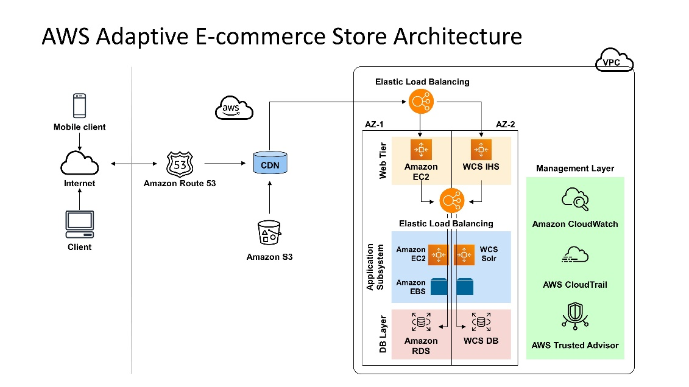

- Why are the EC2 services deployed in multiple AZ? What will happen if I use only one AZ instead of two?.
- What is the purpose of using a CDN?
- Briefly mention two uses of using the Amazon S3 in this diagram

- Refer to the image below and answer the questions Marks 3+1+1 = 5

- Why are the EC2 services deployed in multiple AZ? What will happen if I use only one AZ instead of two?
- What is the purpose of using a CDN?
- Briefly mention two uses of using the Amazon S3 in this diagram

- Refer to the image below and answer the questions Marks = 3+1+1 = 5

- Why are the EC2 services deployed in multiple AZ? What will happen if I use only one AZ instead of two?
- What is the purpose of using a CDN?
- Briefly mention two uses of using the Amazon S3 in this diagram

- Answer in detail Marks = 5
Describe in the core challenges to x86 virtualization and what was done to surmount the challenge.
- Answer in detail Marks = 5
One of the characteristics of cloud as per NIST is it offers an on-demand service. Explain what is meant by On-Demand, and use any service from AWS to provide an illustration of this characteristic.
- Answer in detail Marks = 5

A user in India visits a web page hosted from an Amazon S3 bucket in the US West (Oregon) Region, in the United States. List out the factors that contribute to a slow page load and what can be done to improve latency.

